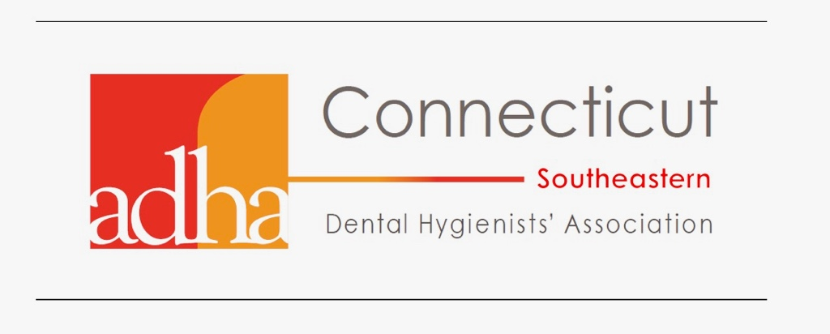
Southeastern Dental Hygienists’ Association
Scholarship Application 2023
(In honor of Alice Fabrykiewicz, RDH & Carmel M. DiLione, RDH)

Applicant Name: ____________________________________________________
Home Address: ____________________________________________________
____________________________________________________
Phone: ____________________________________________________
E-mail (personal): ____________________________________________________
Date of birth: ________________
Dental Hygiene School: ______________________________________________
Degree program:
Associates: ______ Bachelors: _______ Masters: _______
Expected graduation date: _____________ Current GPA: __________
Previous Education:
High School City, State: ______________________________________________
Year graduated: _____________
Previous College (if any): _______________________________________________
Degree(s) Received: _____________________ Dates Attended: __________
List any other honors, awards, or scholarships received: _______________________________________
Final instructions:
- Submit resume or list of past work experience, leadership roles, and volunteer activities.
- Type BRIEF essay telling us what inspired you to go into dental hygiene and /or your objectives for personal & professional growth upon licensure.
- Send unofficial transcripts with most recent grades
- Have one (1) letter of recommendation sent
Signature: _________________________________________ Date: _____________
Please return your application form with supporting data by DEADLINE OF March 15, 2023 to:
Southeastern DHA, Attn: Kimberly Weekley RDH, 143 Phoenix Drive, Groton Ct. 06340
Questions? Email Kim at: webhoo2@yahoo.com

